

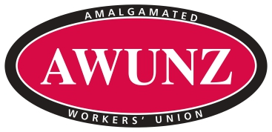

2 April 2020

**PRESS RELEASE: UNION SAYS FLETCHERS CEO AND BOARD OUT OF TOUCH**

Amalgamated Workers Union New Zealand (AWUNZ) has described a take it or leave it offer from Fletcher Building Management to staff as disgraceful.

AWUNZ National Secretary Maurice Davis said the union was more than disappointed with the scheme Fletcher Building had put to staff.

The proposed Covid-19 lockdown 12-week Bridging Pay Programme would see employees required to work continue to receive 100 percent of their based pay while employees not working over the 12-week period would receive 80 percent of their base pay from weeks 1 – 4, 50 percent of their base pay from weeks 5 – 8 and 30 percent of their base pay from weeks 9 to 12.

Accrued and entitled leave could be used to ‘top up’ normal pay. Fletcher senior executives agreed to a 15 percent pay cut through the lockdown period.

“The company has purposely not engaged with the union so this disgraceful deal is all theirs but it is take or leave it offer” Davis said.

“We understand at this moment in time we all must share the pain, but the senior management have decided to take less pain by only cutting their considerable salaries by 15 percent for the whole the 12 weeks while expecting low paid workers to take up to a 70 percent reduction in pay on a sliding time scale.”

“The sense of entitlement shown by CEO Ross Taylor, with the support of the board, shows how out of touch they are with what is going on.”

Davis said the bridging pay programme was a bitter pill to swallow for employees and their families.

“The actions of Fletchers management is obscene.”

He said the AWUNZ delegates had already fielded a number of calls from union members unsure how they would survive on 50 percent of their wage, let alone 30 percent.

“We have the biggest coverage of union membership at Fletchers and some of those companies have been returning large profits, keeping the company liquid up to the lockdown.”

Davis said Fletcher had to show much better leadership through these troubled times, and do what was required to ensure their workforce had the ability to be able to provide for their families.

“We have other tier one companies that have all agreed to the 80 percent minimum during this period - most have had their income stream reduced by 75 percent to 90 percent - but they achieved a fair outcome and engaged with the union to get there unlike Fletcher Building.”

*Maurice Davis - National Secretary – Amalgamated Workers Union – 021 288 5605*